**--------------BASIC DATA CLEANING-------------**

*# Importing libraries---*

**import** numpy **as** np

**import** pandas **as** pd

**import** matplotlib.pyplot **as** plt

**import** seaborn **as** sns

*# Create Dataframe----*

**import** pandas **as** pd

df**=**pd**.**read_csv('Amazon Sale Report.csv',encoding**=** 'unicode_escape')

*# check no of rows and columns---*

df**.**shape

*# get top data--*

df**.**head()

*# get last 5 data---*

df**.**tail()

*# to get info about data---*

df**.**info()

*# to remove un-related/blank column---[(axis=1-column wise delete),(inplace=True--- to delete permanently)]*

*#df.drop(['col. name','col. name'],axis=1,inplace=True)*

*# to check null values---*

pd**.**isnull(df)

*# to get total values of null values---*

df**.**isnull()**.**sum()

*# to get colums names---*

df**.**columns

*# Group-by- group data based on one or more columns in dataframe-----*

*# df.groupby(['column'],as_index=False['column1'].sum().sort_values(by='column1'),ascending=False)*

*# as_index parameter is used to determine whether the grouping columns should be set as the index of the resulting DataFrame.*

*# as_index=True (the default), the grouping columns become the index, and the aggregated data is organized accordingly.*

*# to remove/drop null values---*

df**.**dropna(inplace**=True**)

*# check null values---*

df**.**shape

*# get column names---*

df**.**columns

*# change data type---*

df['ship-postal-code']**=**df['ship-postal-code']**.**astype('int')

*# check data type---*

df['ship-postal-code']**.**dtype

*# change date data type---*

df['Date']**=**pd**.**to_datetime(df['Date'])

*# to rename column name---*

df**.**rename(columns**=**{'Qty':'Quantity'},inplace**=True**)

*# checking for rename of column----*

df**.**columns

*# to check for description of data in dataframe such as mean,std. deviation,count etc...describe() is only used for numerical data.*

df**.**describe()

*# to check for description of objects-----*

df**.**describe(include**=**'object')

*# to check description for particular/specific columns---*

df[['Quantity','Amount']]**.**describe()

**------------EXPLORATORY DATA ANALYSIS----------**

**SIZE BASED ANALYSIS**

*# checking for rename of column----*

df**.**columns

Index(['Index', 'Order ID', 'Date', 'Status', 'Fulfilment', 'Sales Channel',

'ship-service-level', 'Category', 'Size', 'Courier Status', 'Quantity',

'currency', 'Amount', 'ship-city', 'ship-state', 'ship-postal-code',

'ship-country', 'B2B', 'fulfilled-by'],

dtype='object')

*# count-plot based on size------*

sz**=**sns**.**countplot(x**=**'Size',data**=**df,hue**=**'Size')

**for** bars **in** sz**.**containers:

sz**.**bar_label(bars)

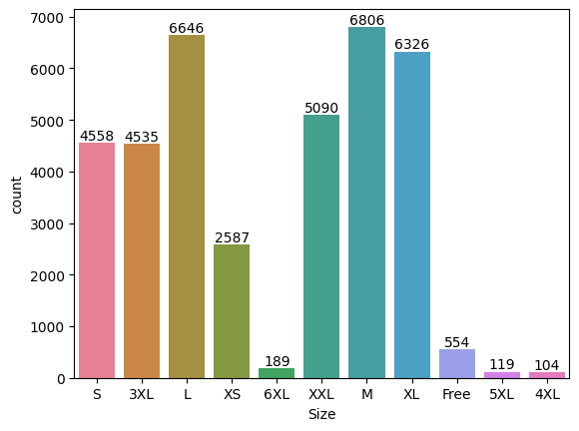

**NOTE: From graph it can be interpreted that most people buys M-size and 4XL is least buy product.**

*# sorting data based on size and qunatity-----*

S_Qty**=**df**.**groupby(['Size'],as_index**=False**)['Quantity']**.**sum()**.**sort_values(by**=**'Quantity',ascending**=False**)**.**head(10)

*# plotting bar-plot for sorted data-----*

sns**.**barplot(x**=**'Size',y**=**'Quantity',data**=**S_Qty,hue**=**'Size')

<Axes: xlabel='Size', ylabel='Quantity'>

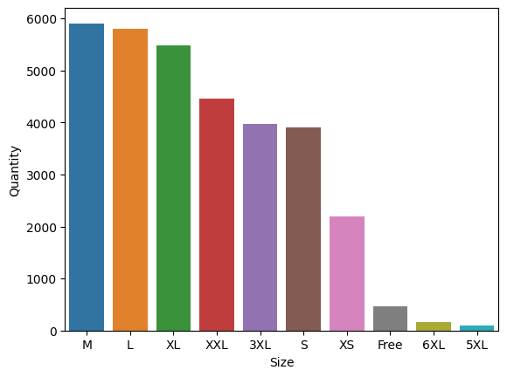

**NOTE:From Above graph we can analyze medium size is the most buyed quantity in sales.**

**COURIER STATUS BASED ANALYSIS**

cs**=**sns**.**countplot(x**=**'Courier Status',data**=**df,hue**=**'Status')

*# set bar-size to avoid overlapping--*

sns**.**set(rc**=**{'figure.figsize':(15,5)})

*# plt.figure(figsize=(10,5))*

**for** bars **in** cs**.**containers:

cs**.**bar_label(bars)

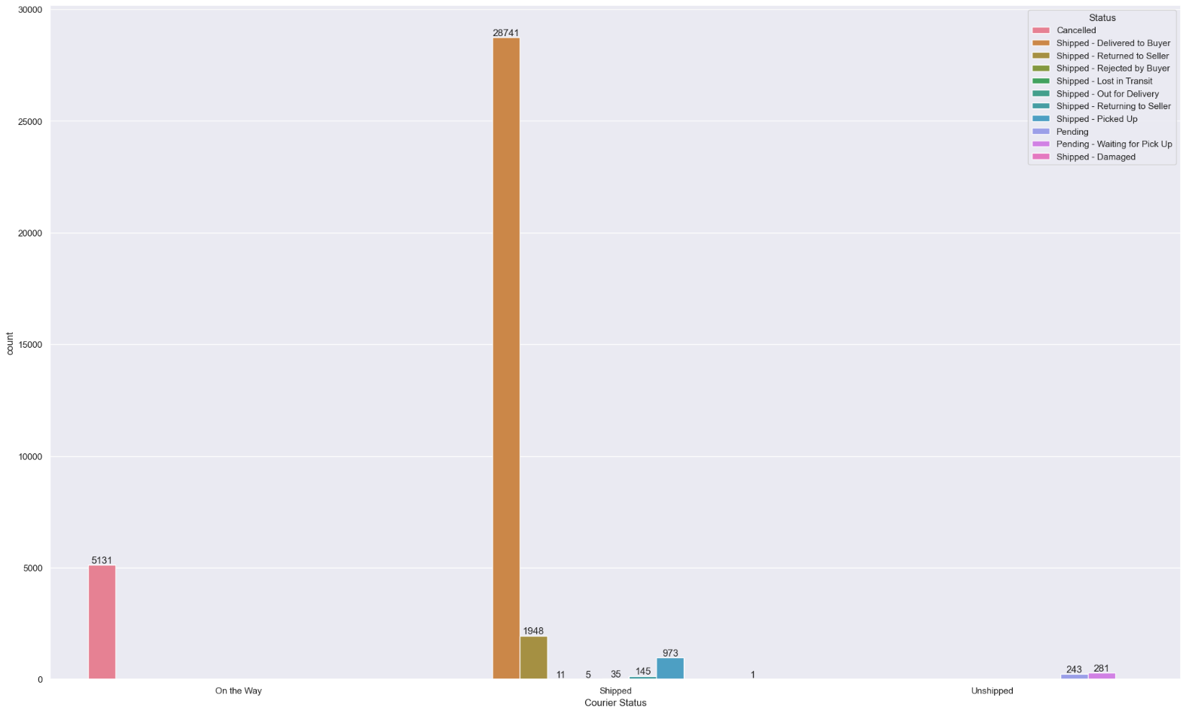

**NOTE: From above graph it can be inferred that most orders are shipped through couriers.**

In [82]:

*# plotting histogram graph for size---*

df['Size']**.**hist()

*# to get grid-lines---*

plt**.**grid

plt**.**show()

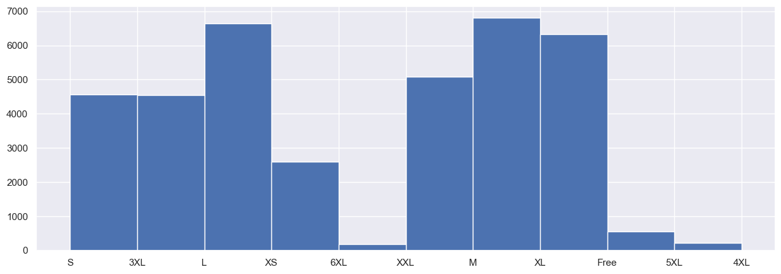

**CATEGORY BASED ANALYSIS**

*# changing CATEGORY datatype from 'OBJECT' TO 'STRING'---*

df['Category']**=**df['Category']**.**astype(str)

Column_data**=**df['Category']

*# changing figure size--*

plt**.**figure(figsize**=**(15,5))

*# plotting histogram plot for category---*

plt**.**hist(Column_data,bins**=**30,edgecolor**=**'Black')

*# rotating x-axis data---*

plt**.**xticks(rotation**=**90)

*# x and y axis labels--*

plt**.**xlabel('category--')

plt**.**ylabel('quantity--')

plt**.**show()

*# histtype='bar'/'barstacked'/'step'/'stepfilled'*

*# cumulative=-1-reverse frequency of graph*

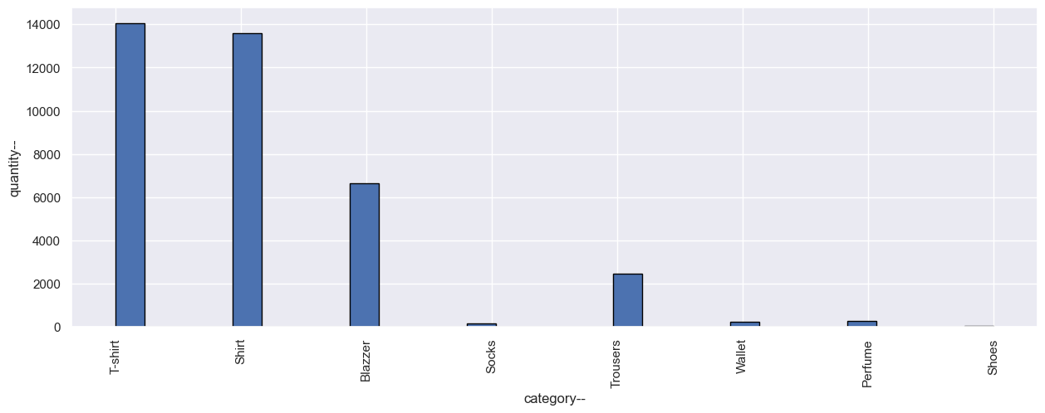

**NOTE: From graph it can be infered that most buyed product is T-Shirt, Shirt and Blazzer.**

**Checking B2B Data Analysis**

*# value count for B2B---*

Check_B2B**=**df['B2B']**.**value_counts()

*# plotting pie-chart--*

plt**.**pie(Check_B2B,labels**=**Check_B2B**.**index,autopct**=**'%1.1f%%')

plt**.**show()

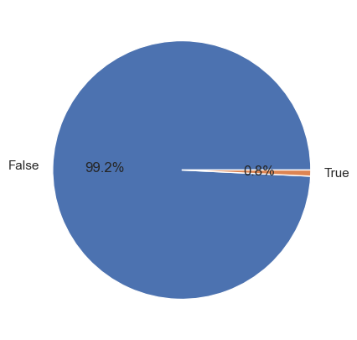

**NOTE: From pie-chart it is infered that 99.2% are retailers and 0.8% are B2B buyers.**

**Category vs Size analysis**

x_data**=**df['Category']

y_data**=**df['Size']

*# plotting scatter graph--*

plt**.**scatter(x_data,y_data)

plt**.**xlabel('Category--')

plt**.**ylabel('Size--')

plt**.**title('Category vs Size')

plt**.**show()

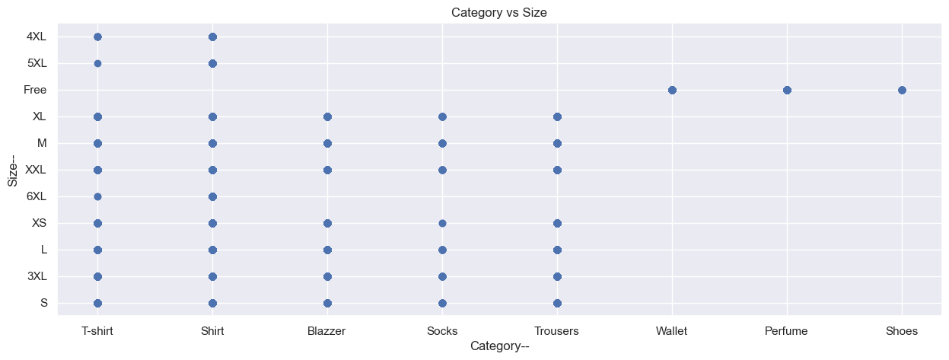

**Cities vs State Analysis**

*# set figure size*

plt**.**figure(figsize**=**(12,6))

sns**.**countplot(x**=**'ship-state',data**=**df,hue**=**'ship-state')

*# labeling--*

plt**.**xlabel('Shippped State--')

plt**.**ylabel('count of cities--')

*# title--*

plt**.**title('Distribution of states')

plt**.**xticks(rotation**=**90)

plt**.**show()

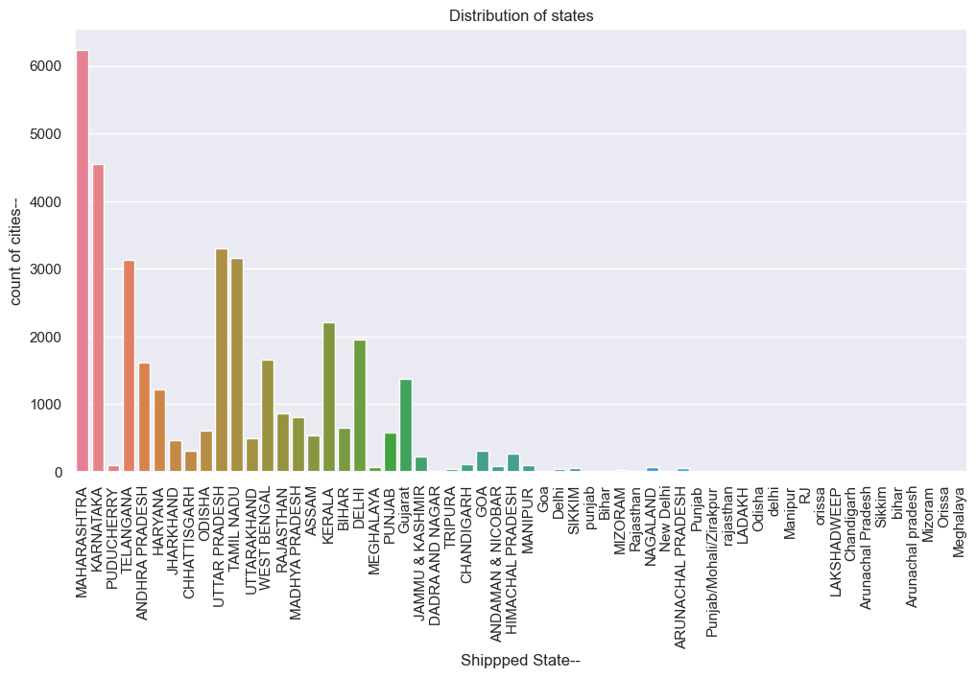

**NOTE:From above graph it is infered that most buyers are from Maharashtra state.**

**CONCLUSION:**

The data analysis reveals that business has significant customer base in Maharashtra state,serving mostly retailers,orders are fulfilled by Amazon. Medium sized T-shirt are in high demand amomg buyers.